Project Proposal

G.L.A.P.S.

(Geographic Location Attribute Predictor System)

Description: This project is a collaborative effort of two (2) teams from Fayetteville Technical Community College (FTCC) to develop software that will use data collected from the U.S. Census to predict the property value of the surrounding area where a stadium is being built.

Collaborators:

(Back-end team)

Gabriela Canjura [canjurag4010@student.faytechcc.edu](mailto:canjurag4010@student.faytechcc.edu)

Mallory Milstead [milsteam4144@student.faytechcc.edu](mailto:milsteam4144@student.faytechcc.edu)

(Front-end team)

Brian Schweikart [schweikartb0866@student.faytechcc.edu](mailto:schweikartb0866@student.faytechcc.edu)

Jesse Watts [wattsj2683@student.faytechcc.edu](mailto:wattsj2683@student.faytechcc.edu)

Scope:

The program is written using Python, SQL, Flask, and CSS. The webpage will display information containing the name of the software, what it’s supposed to do, and how to log in & use the software. The user will be able to enter his/her username & password or register for a new account.

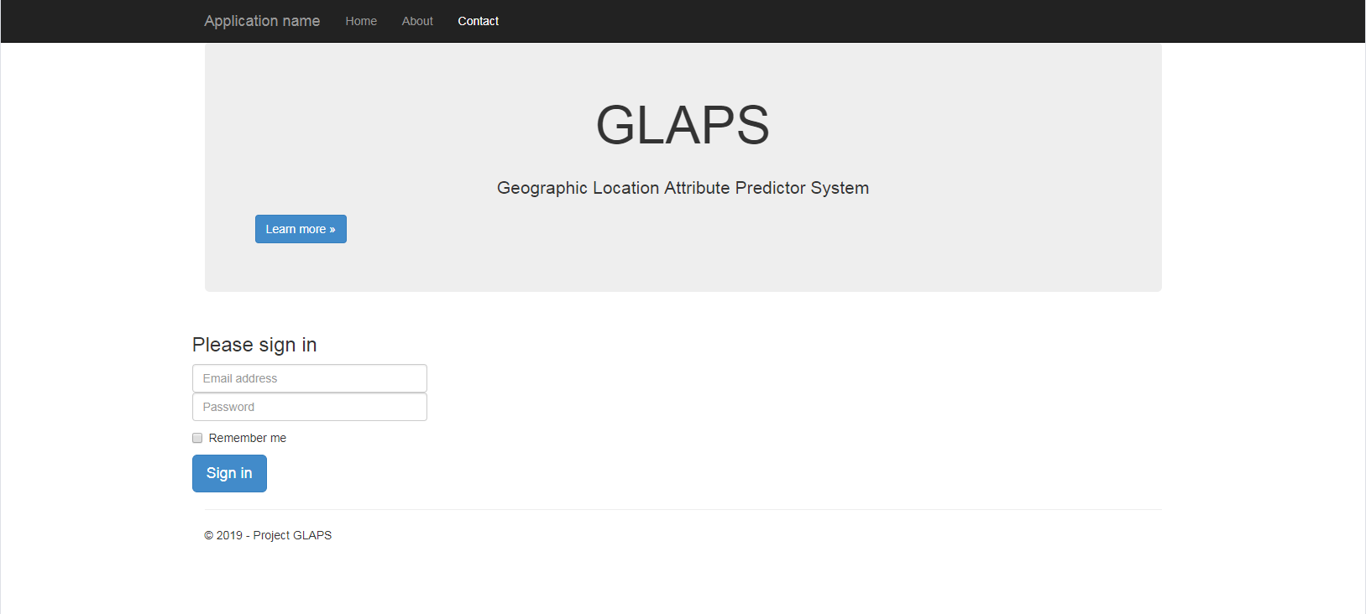

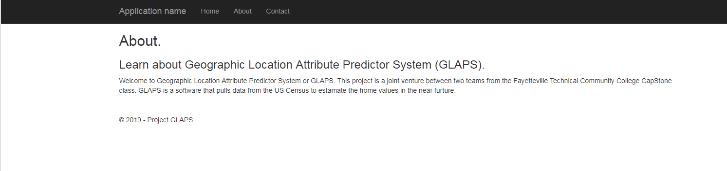

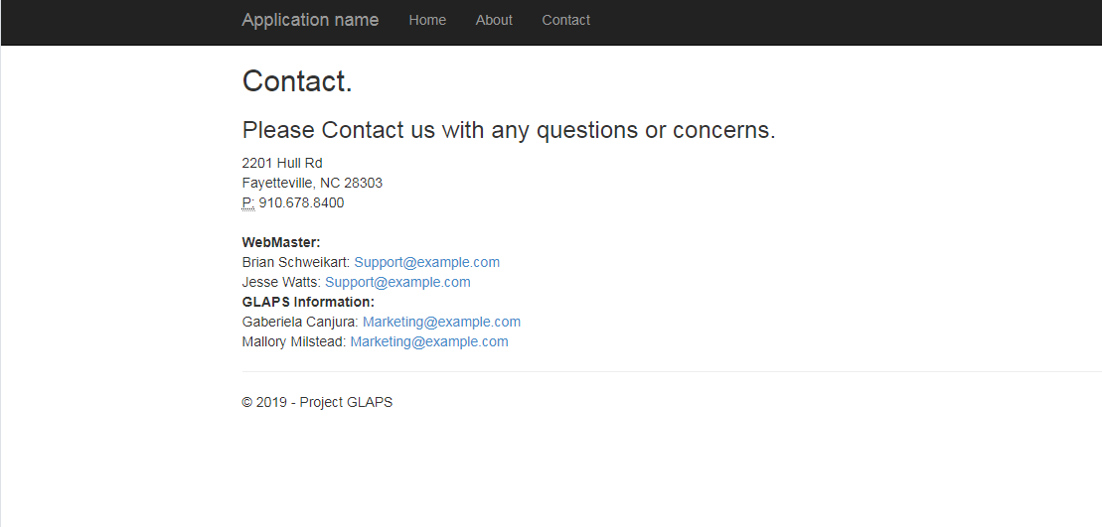

The database will be used to hold the users first & last name, email address, username, & password. The user must enter a unique username & email address to be stored in the database. If the system finds a duplicate, it will return an error and ask the user to enter a new username. Later in the development, we will bridge it to the back-end’s database so that if there is information in either database, it can be pulled back & forth with no issues.

The concept is that once a user is registered and created an account, he/she will be able to use the software in order to view property values in areas and predict the increase/decrease of those areas based on stadiums being constructed in those areas. However, this software has the potential to be updated to accept other geographic areas & explore property values based on other calculations determined by various construction projects.